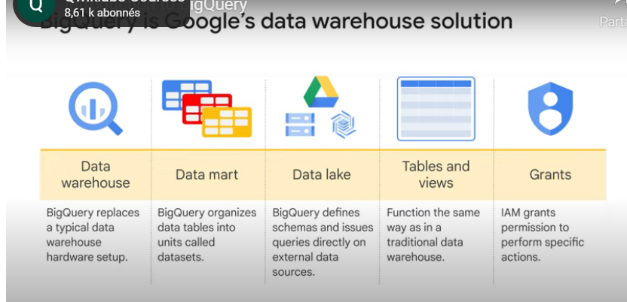

Computing power is allocated automatically, no need to buy anything before beginning querying => Saves money